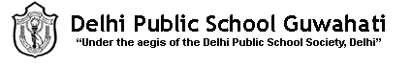
BIOLOGY SUMMER HOLIDAY HW 2022-23
CLASS X
- Completion of competency based questions of chapter 6- Life processes (uploaded in school website).
- Lab file work (Part of subject enrichment)
Experiment (to be written in lab file):
- Preparation of temporary mount of leaf peel to observe stomata.
- Experimentally show that carbon dioxide is given out during respiration.
- To experimentally show that light is necessary for photosynthesis.

